**How to enable User and Group Disk Quota on ext4**

Quota restricts the users to use only allowed **disk** and **inodes** on the particular file system.

##### Step:1 Add usrquota & grpquota option on /home in /etc/fstab file.

[root@linuxtechi ~]# vi /etc/fstab

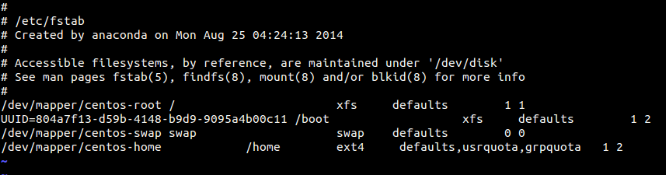

Save & exit the file.

In this example user and group quota options are added on /home

##### Step:2 Remount  /home file system via  mount command

[root@linuxtechi ~]# mount -o remount /home

Now recheck the /home file system whether Quota is enable or not.

[root@linuxtechi ~]# mount | grep /home

/dev/mapper/centos-home on /home type ext4 (rw,relatime,seclabel,quota,usrquota,grpquota,data=ordered)

##### Step:3 Create Quota Database Files using quotacheck

[root@linuxtechi home]# quotacheck -cugv /home

Whereas :

-c : create quota file and don’t use the existing file  
-v : verbose ouput  
-u : user disk quota  
-g : group disk quota

Above Command will create aquota.user & aquota.group files under /home

Turn on quota on /home using below command :

[root@linuxtechi ~]# quotaon /home/

##### Step:4 Assign user & group disk quota via edquota commands

Syntax # edquota -u <User_Name>

# edquota -g <Group_Name>

[root@linuxtechi ~]# edquota -u jack



[root@linuxtechi ~]# edquota -g sys_admin



As shown above we have two kind of **Disk quota limits** :

**soft** : It will warn the users if the soft limit of disk quota reached ( size is in KB), in above example for jack user soft limit is 5500 KB ( approx 5.5MB )

**hard** : It will not allow the users to create new files once the hard limit is reached. ( Size in KB ), in above example hard limit for jack user is 6000 KB ( approx 6 MB )

**Note** : We can also set the Quota on the basis of the inodes ( i.e numbers of files that the user can create on particular file system)

Let’s take an example , login as jack user and try to create a file of 8MB.

[root@linuxtechi ~]# su - jack

[jack@linuxtechi ~]$ dd if=/dev/zero of=bgfile bs=1M count=8

dm-2: warning, user block quota exceeded.

dm-2: write failed, user block limit reached.

dd: error writing ‘bgfile’: Disk quota exceeded

6+0 records in

5+0 records out

6144000 bytes (6.1 MB) copied, 0.00711317 s, 864 MB/s

As we see above soft & hard limit is exceeded for jack user. Now onwards user jack can’t create new files.

##### Step:5 Display Quota report for Users in human readable

[root@linuxtechi ~]# repquota -as

##### Step:6 Configure Grace Period for Soft Limit

Grace period is the amount of time during which soft limit can can be exceeded, once the grace period reached then soft limit will become the hard limit.

Use the edquota command to set grace period ,

[root@linuxtechi ~]# edquota -t

